FQDN update process
-----------===============--------------
Step 1. Go to settings My Deployment Select MPE pool and disable the HA

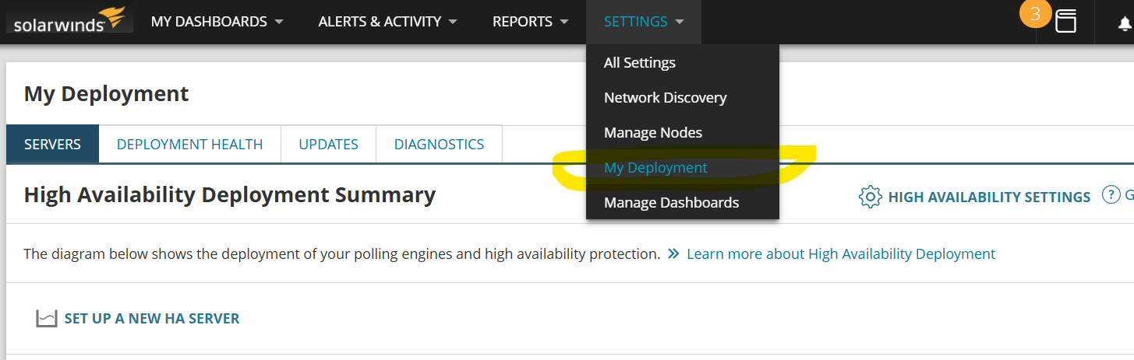

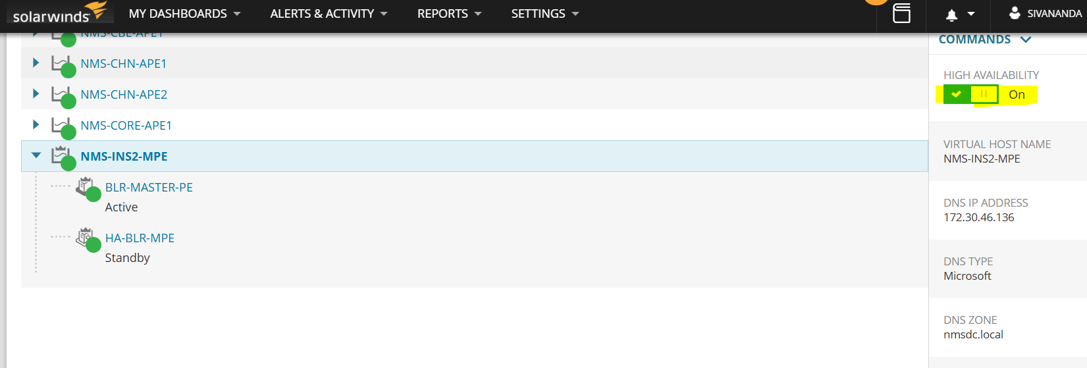
Step 2. Login to MPE server and stop the Module Engine

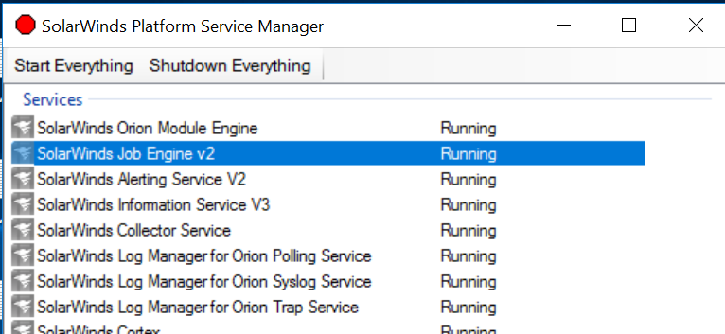

Step 3.Open DB and select Website settings table

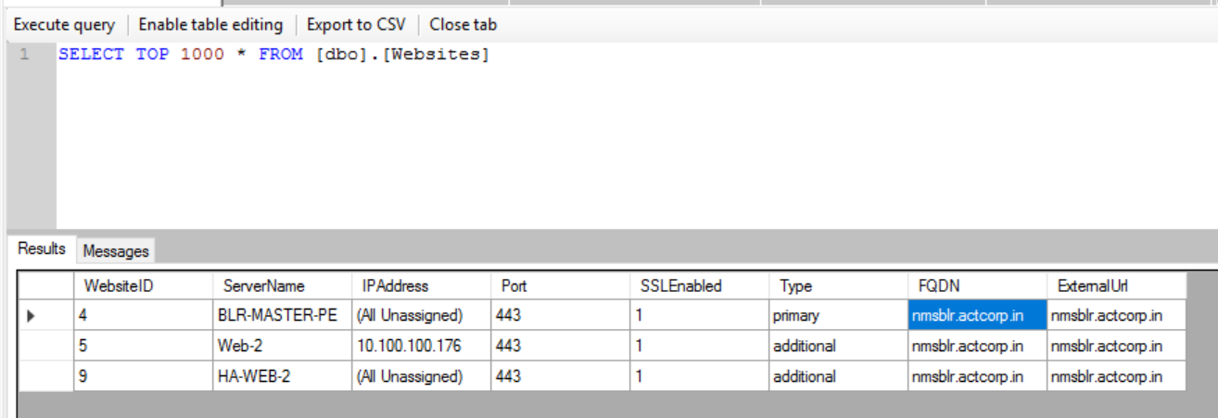

Step 4. Check the server name column and click on enable table editing to update FQDN.

Step 5. Update the FQDN column with value nmsblr.actcorp.in for instance-2 ( nmshyd.actcorp.in) for instance-1.

Step 6. Click on execute query again and check the status of the server name with FQDN value, is updated or not.

Step 7. Start the Module Engine service.

Step 8. After updating FQDN check any sample schedule report and job running or not.

Step 9. Go to settings My Deployment Select MPE pool and enable the HA.

